Snort Installation

1. Install Snort on Ubuntu
Step 1: Update System
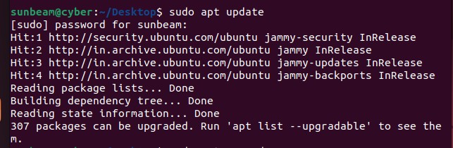
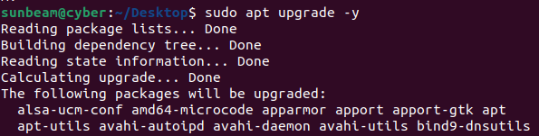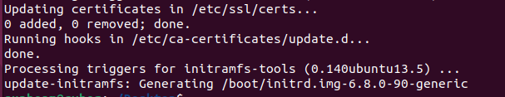
Step 2: Install Dependencies
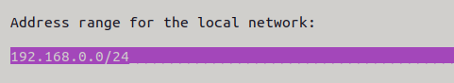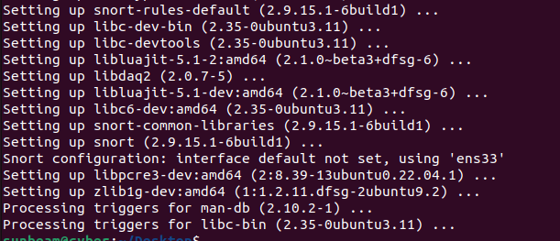
Step 3: Verify Snort Installation
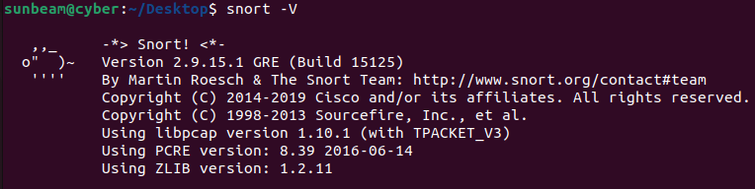

2. Configure Snort
Step 1: Find Network Interface
Step 2: Edit Snort Configuration
Modify:
Set network range
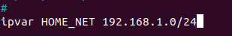

Find: var RULE_PATH ../rules
Replace : var RULE_PATH /etc/snort/rules
Step 3: Create Snort Rule File
Create a custom rule file: sudo nano /etc/snort/rules/local.rules
Add a test rule
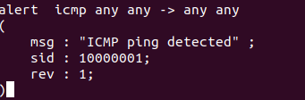
4. Running Snort
Step 1: Test Snort Configuration
sudo snort -T -i ens33 -c /etc/snort/snort.conf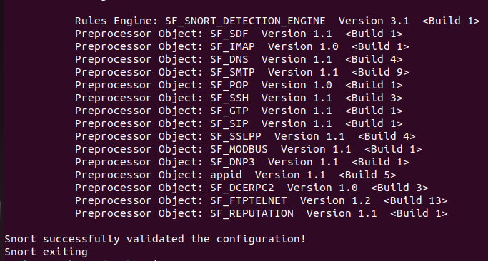

Step 2: Start Snort in IDS Mode
sudo snort -A console -q -i ens33 -c /etc/snort/snort.conf
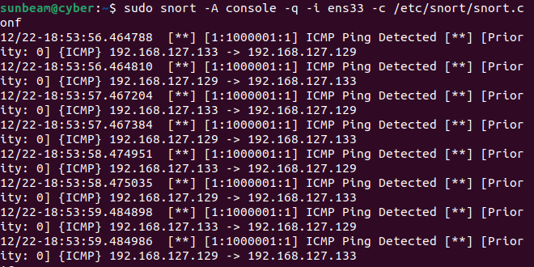
Step 3: Generate a Test Attack (ICMP Ping)
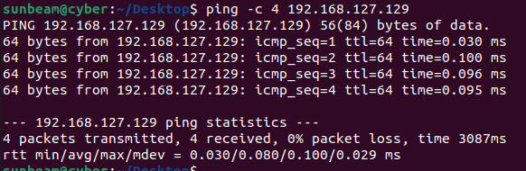

5. Reporting & Logs
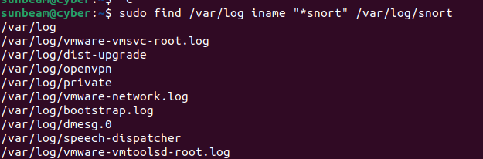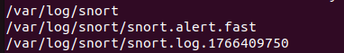

Snort logs alert

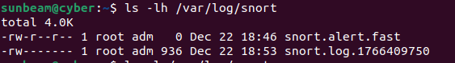

For real-time monitoring
